8/18/2020

Syntia

FUTURE 4.0 Phase 3

PRD - TailorMade

You dream it, we make it true

## General ****Description****

TailorMade is a mobile application which connects customer with tailors and fashion designers, so every customer be able to get the clothes he/she want faster. Customer may use the application with 3 steps:

* **modelling (by searching for a design or using his/her own design),**
* **matching (make some negotiation or fitting with the tailor), and**
* **making (order the clothes).**

**There are some similar apps that related to this application, such as TailorMate**[1] **apps, which is made for tailors to manage their products design and orders. There are also some similar websites, one of them is tailoringneeds**[2]**, for finding nearby tailors and book them. Customers also be able to leave a review to booked tailors.**

**Main differences between TailorMade with another apps and website can be shown in the table.**

|  |  |  |  |
| --- | --- | --- | --- |
|  | ****TailorMade**** | ****TailorMate**** | ****TailoringNeeds**** |
| **Goals** | 1. **Connects customer with tailors** 2. **Design negotiation and customization** 3. **Make online transactions** | 1. **Manage tailor’s orders and products design** | 1. **Search for nearby tailors** 2. **Book a tailor** 3. **Review the tailor** |
| **Persona(s)** | * **Tailor** * **User** | * **Tailor** | * **Tailor** * **User** |

## ****Motivation****

Clothes is one of the primary needs that can’t be separated from daily needs. In some events, such as wedding or school farewell party, people tend to need clothes which can be customized as they wish. Hence, people have to find shop, tailor or convection business who are able to make the clothes, according to the design quality and price. This creates a problem, where not all parties who can make the desired clothes are in an accessible location. Other than that, sometimes customer and tailor think that another variable such as cloth quality and offered price isn’t match.

From tailor’s perspective, it’s difficult to produce clothes customer wants because of his/her high expectations for the clothes. The tailors themselves have variety of skills so they cannot make the clothes that customers want to the fullest.

TailorMade would be the solution of the problems. TailorMade is an e-commerce that connects tailors and customers. It introduces technology and e-commerce for customers and tailors as a place to make online transactions. This makes it easier for customers to find a tailor and make transactions without the need to meet the tailor first. Customers can also find the right tailor to create the desired clothes design, because there are examples of designs that have been made by the tailor. In addition, the process of customization and negotiation is also facilitated by online communication, allowing tailors to better understand what customers want.

## ****Competitive Analysis****

### TailorMate vs TailorMade

In TailorMate, application is designed to manage tailor’s job, such as product, customer, and order management. They will be added and saved to the application manually by tailors. The orders’ progress also can be updated. Moreover, transaction reports will be generated from all saved orders. UI of TailorMate’s main features can be seen at the following images.

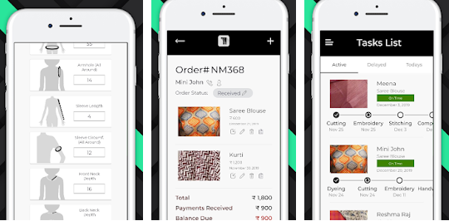

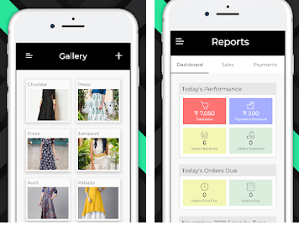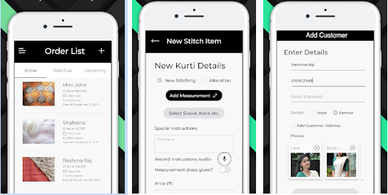

From the observation results, it can be shown that TailorMate isn’t handling customer needs. The reason is this application made for managing tailors need. The advantage of TailorMade than this apps is there are applications that can be used by customers, so tailors and customers can be connected without time and place difference. Besides self-branding, tailor doesn’t need to add customer and order data manually.

### TailoringNeeds vs TailorMade

Tailoringneeds website is similar to the apps by the goals. The difference is in the concept from solution of the problems. Customer be able to choose how to find the tailor nearby him/her, or at another location. Customer also be able to book the tailor to make a transaction. After ordering process, customer may send any review to the tailor. UI of the website main features can be seen at the following images.

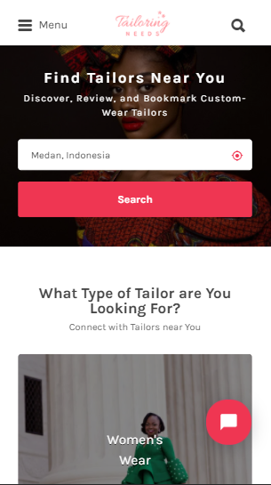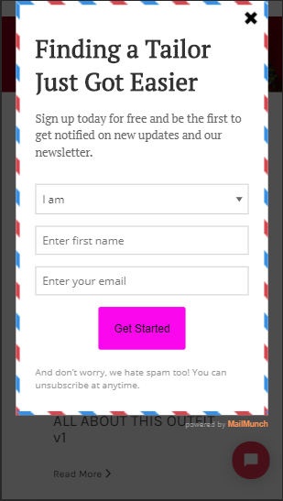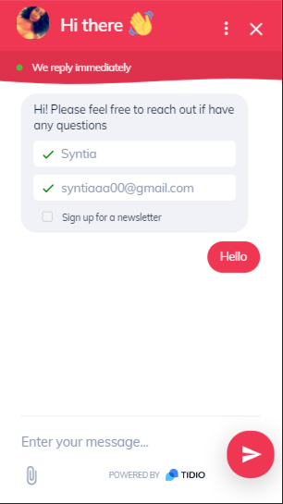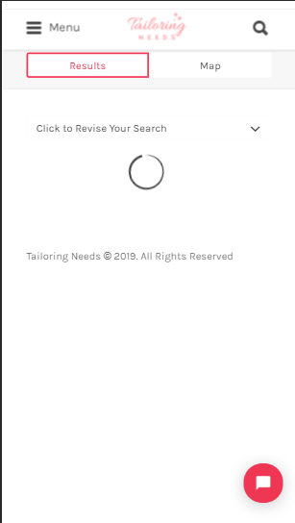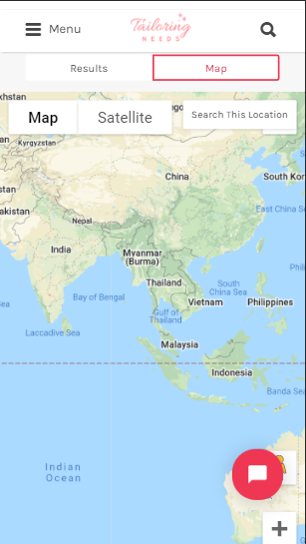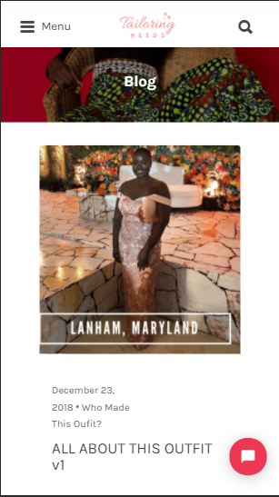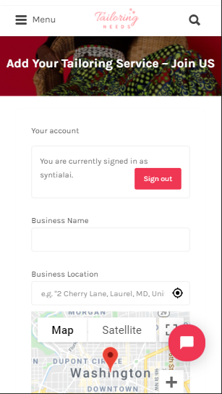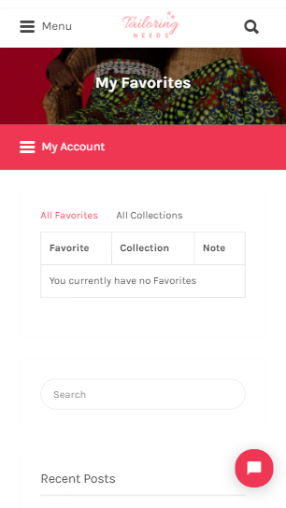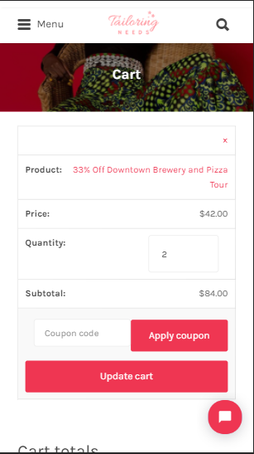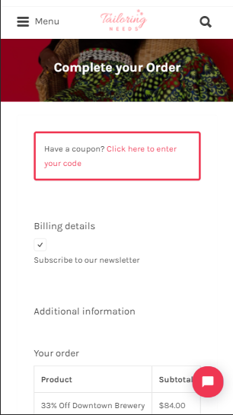

From the observation result, it can be shown that tailoringneeds websites is available for customer and tailor, which the customer also may be the tailor with tailoring service. The advantage TailorMade of than this website is the apps provides show and search designs feature, so customer may find design he/she wants faster. Besides, customer also easier to chat the tailor and make some negotiation and customization on the design chosen. Customer be able to order the design. From the tailor perspective, besides self-branding, tailors also be able to determine when will the design order finished.

## Goals

Users will be able to:

* Find designs and tailors faster
* Communicate and negotiate with the tailor via chat
* Order a design

Tailors will be able to:

* Manage all designs and publish to the system
* Promote their account and share location
* Communicate and negotiate with the user via chat
* Accept/reject user’s order

Project’s requirements:

* Successfully implement the apps idea with maintainable code and publish to an app store
* Unit testing (min. 95%) and automation testing (optional, 30 – 50%)
* Implements docker and jenkins for CI/CD (optional)
* Complete and fully updated documentations (SRS, mockup, API Specs)

## Key Path Scenarios

### Signed_in user

Before entering the app, user must have an account. User will be asked to log in with an account or sign up to create a new account. After logged in or signed up, system will show the Home page. User can access some main page from the bottom navigation menu, such as Home page, Cart page, Chat page, and Profile page. From the Home page, user can show, search, sort and filter all registered tailors. User click one of the designs. System will show the Design Detail page. From this page, user can contact the tailor and send the design directly. User can swap face in the design by tapping Swap Face button. User simply upload photo to change face and system will show the swapped design face. User will be able to download or share the photo. User also can order the design. When user order the design, system will show the Cart page. then user may tap checkout button to show the Order page. In the Order page, user can add some notes for customization and set size of the design cloth. After ordering the design, user can show the ordered design at the History Order pages. User also can show Order Detail by clicking one of the orders. User tap chat menu from navigation. From the Chat page, user can show all chats with the tailor. User tap one of the chats. User can show the chat with a tailor. User can send message or attach an image to the chat. From the Chat page, user tap profile menu. System shows the Profile page. Users can update his/her account information, go to some general settings and log out from the account.

### Tailor

Before entering the app, tailor must have an account. Tailor will be asked to log in with an account or sign up to create a new account. After logged in or signed up, system will show the Home page for tailor. From the Home page, tailor can show all designs added by the tailor, sorted by the newest, and add a design. Tailor tap Add button. System will show the Add Design form. Tailor should fill the required field. Tailor tap the Add Design button. System will add the design to pending design. The design will be reviewed and will be shown to user after approved. Tailor can tap one of the designs. System will show the Design Detail page. Tailor can update the design information. From the bottom navigation menu, tailor tap the order menu. System will show the Order page. From the Order page, tailor can show some order that requested by user. Tailor can accept or reject order from the user. Tailor tap the profile menu. System shows the Profile page. User can update his/her account information, go to some general settings and log out from the account.

## Feature Description & Design

Mockup akan di-*update* segera.

### Login

|  |  |
| --- | --- |
| Feature | *Login* |
| Description | *User can log in to their account* |
| Purpose | *To use the app as signed_in user or tailor* |
| User problem | *User can’t use the app* |
| User value | *User logged in to their account so they can use provided features in the app* |
| Assumptions | *User just installed the app for the first time* |
| Not doing | *-* |
| Acceptance criteria | 1. *User in a role of guest user* 2. *User open the Login page* 3. *System shows the Login form containing Email and Password fields which are required* 4. *User fill in the Email field with a valid email address* 5. *User fill in the Password field with password* 6. *User press Enter in the Password field or User tap the Log in button* 7. *System shows the Home page* |

### Sign up

|  |  |
| --- | --- |
| Feature | *Sign up* |
| Description | *User can register for a new account* |
| Purpose | *To make a new account to use app as signed_in user or tailor* |
| User problem | *User doesn’t have an account* |
| User value | *User have an account and logged in to their account so they can use provided features in the app* |
| Assumptions | *User doesn’t have an account* |
| Not doing | *-* |
| Acceptance criteria | 1. *User in a role of guest user* 2. *User open the Signup page* 3. *System shows the Signup form containing some fields which are required (Name, Gender, Email, Password, Confirm Password)* 4. *User fill in the Name field with a valid name* 5. *User choose one of the Gender option* 6. *User fill in the Email field with a valid email address* 7. *User fill in the Password field with password* 8. *User fill in the Confirm Password field with same password as in the Password field* 9. *User tap the Sign up button* 10. *System logged user in* 11. *System shows the Home page* |

### Home

|  |  |
| --- | --- |
| Feature | *Home* |
| Description | *Signed_in user can show all tailor’s design based on interest, search, sort and filtering the design* |
| Purpose | 1. *To show all design made by tailors* 2. *To find the design that user want* |
| User problem | *User want to show and search design* |
| User value | 1. *Signed_in user will show the design based on his/her interest.* 2. *Signed_in user can also search, sort and filtering the design so he/she can find the design faster* |
| Assumptions | *User in a role of signed_in user* |
| Not doing | *-* |
| Acceptance criteria | 1. *User in a role of signed_in user* 2. *User open the Home page* 3. *System shows the Home page with design images, including search, sort and filter options* 4. *User tap the Sort button*    1. *System shows some options to sort by*    2. *User tap one of the options*    3. *System shows design that sorted by the options* 5. *User tap the Filter button*    1. *System shows some category to filter*    2. *User fill some category to filter*    3. *User tap the Filter button*    4. *System shows design that filtered by the chosen category* 6. *User tap a design* 7. *System shows the Design Detail page* |

### Design Face Swap

|  |  |
| --- | --- |
| Feature | *Design Face Swap* |
| Description | *Signed_in user can swap design’s face with his/her own face to make sure that design will fit him/her.* |
| Purpose | 1. *To swap tailor design’s face with user’s face* |
| User problem | *User want to show that clothes will fit him/her by putting his/her face to the design* |
| User value | 1. *Signed_in user will be able to swap design’s face with uploaded photo.* 2. *Signed_in user can also save the swapped design’s face to gallery and share the photo.* |
| Assumptions | *User in a role of signed_in user* |
| Not doing | *-* |
| Acceptance criteria | 1. *User in a role of signed_in user* 2. *User open the Home page* 3. *System shows the Home page with design images, including search, sort and filter options* 4. *User tap a design* 5. *System shows the Design Detail page* 6. *User tap Swap Face button*    1. *System will ask user to upload a photo*    2. *User tap Choose Photo button*    3. *User choose to take a photo or from the gallery*    4. *User upload the photo*    5. *System navigate to show the swapped face photo*    6. *User tap the download icon button*    7. *System saves the photo to gallery*    8. *User tap the share icon button*    9. *System shows the modal to share the photo* |

### Tailors

|  |  |
| --- | --- |
| Feature | *Tailors* |
| Description | *Signed_in user can show all tailor, search, sort and filtering the tailor* |
| Purpose | 1. *To show all registered tailors* 2. *To find the tailor that fits user’s design* |
| User problem | *User want to show and search tailor* |
| User value | *Signed_in user can search, sort and filtering the tailor so he/she can find the tailor faster* |
| Assumptions | *User in a role of signed_in user* |
| Not doing | *-* |
| Acceptance criteria | 1. *User in a role of signed_in user* 2. *User open the Tailors page* 3. *System shows the Tailors page with list of tailors, including search, sort, and filter options* 4. *User tap the Sort button*    1. *System shows some options to sort by*    2. *User tap one of the options*    3. *System shows tailor that sorted by the options* 5. *User tap the Filter button*    1. *System shows some category to filter*    2. *User fill some category to filter*    3. *User tap the Filter button*    4. *System shows tailor that filtered by the chosen category* 6. *User tap a tailor* 7. *System shows the Tailor Details page* |

### Chat with Tailor

|  |  |
| --- | --- |
| Feature | *Chat with Tailor* |
| Description | *Signed_in user can chat the tailor for customize and negotiation* |
| Purpose | *To chat the tailor and make some negotiation, such as pricing and design customization* |
| User problem | *User want to contact the tailor for asking about the design* |
| User value | *Signed_in user will be able to contact the tailor from the chat feature.* |
| Assumptions | *User in a role of signed_in user* |
| Not doing | *-* |
| Acceptance criteria | 1. *User in a role of signed_in user* 2. *User tap the Chat icon from the Design Detail page, or User tap the Chat button from the Tailor Detail page* 3. *System shows the Chat Detail page with the tailor* 4. *User can fill in the Chat field to contact the tailor*    1. *User press Enter key or tap the Send icon*    2. *System shows the chat that user send* 5. *User can send a picture in the Chat*    1. *User tap the Camera icon*    2. *User can send image from camera or gallery*    3. *User choose an image*    4. *User tap the Send button*    5. *System shows the image that user send in the chat* |

### Order Design

|  |  |
| --- | --- |
| Feature | *Order Design* |
| Description | *Signed_in user can order a design* |
| Purpose | *To order a design* |
| User problem | *User want to order a design from the app* |
| User value | *Signed_in user will be able to order the design* |
| Assumptions | *User in a role of signed_in user* |
| Not doing | *-* |
| Acceptance criteria | 1. *User in a role of signed_in user* 2. *User tap the Checkout button from the Design Detail page* 3. *System shows the Order page with design and tailor information, and Order Now button.* 4. *User can fill Note field with some customize options* 5. *User tap the Order Now button.* 6. *System make an order to the user and tailor.* 7. *System shows the Order Detail page.* |

### Profile

|  |  |
| --- | --- |
| Feature | *Signed_user’s Profile* |
| Description | *Feature to update profile info and some settings including log out* |
| Purpose | *To update profile info and some settings including log out* |
| User problem | 1. *Signed_user want to update his/her profile information* 2. *Signed_user want to set some general settings* 3. *Signed_user want to log out of his/her account* |
| User value | *Signed_user can update profile, set default settings, and log out of their account* |
| Assumptions | *User in a role of signed_user* |
| Not doing | *-* |
| Acceptance criteria | 1. *User in a role of signed_user* 2. *User open the Profile page* 3. *System shows user information, Edit button, and the Settings icon* 4. *User tap the Edit button*    1. *System shows the User form to update profile with filled saved value in some field*    2. *User update the information in the field*    3. *User tap the Update Profile button*    4. *System shows a “Successfully updated your info!” toast*    5. *System redirect to Profile page* 5. *User tap the Settings icon*    1. *System shows list of general settings*    2. *User tap one of the settings*    3. *System shows the chosen Settings form to update setting*    4. *User tap the log out list in the settings*    5. *System shows the Log in page* |

### CRUD Tailor’s Design

|  |  |
| --- | --- |
| Feature | *CRUD Tailor’s Design* |
| Description | *Feature to create, read, update, and delete design* |
| Purpose | *To manage all tailor’s designs* |
| User problem | *Tailor want to see all design added and manage it* |
| User value | *Tailor can create, read, update and delete his/her design* |
| Assumptions | *User in a role of tailor* |
| Not doing | *-* |
| Acceptance criteria | 1. *User in a role of tailor* 2. *User is in landing page* 3. *System shows all designs added by user* 4. *User tap the Add button*    1. *System shows the Add Design form with some required field*    2. *User upload an image to the form*    3. *User filled the required field*    4. *User tap the Add Design button*    5. *System shows a “Successfully added design!” toast*    6. *System redirect to Home page* 5. *User tap one of the design* 6. *System shows the Design Detail page, with design information, Update and Delete button* 7. *User tap the Update button*    1. *System shows the Update Design form with filled required field*    2. *User edit some required field*    3. *User tap the Update Design button*    4. *System shows a “Successfully updated design!” toast*    5. *System redirect to Design Detail page* 8. *User tap the Delete button*    1. *System shows the confirm modal with warning description, Cancel and Delete button*    2. *User tap the Delete button*    3. *System shows a “Successfully deleted design!” toast*    4. *System redirect to Home page* |

### Manage Tailor’s Incoming Order

|  |  |
| --- | --- |
| Feature | *Manage Tailor’s Incoming Order* |
| Description | *Feature to manage tailor’s incoming order* |
| Purpose | *To manage tailor’s incoming order* |
| User problem | *Tailor want to accept/reject incoming order by signed_user* |
| User value | *Tailor can show all incoming order, and accept or reject the order* |
| Assumptions | *User in a role of tailor* |
| Not doing | *-* |
| Acceptance criteria | 1. *User in a role of tailor* 2. *User open the Order page* 3. *System shows all incoming order from signed_user to the tailor in the Incoming tabs* 4. *User tap the Accept button at one of the incoming order*    1. *System shows a “Successfully accepted order!” toast*    2. *System removed accepted incoming order card* 5. *User tap the Reject button at one of the incoming order*    1. *System shows a “Successfully rejected order!” toast*    2. *System removed rejected incoming order card User filled the required field* 6. *User tap the Recent navigation tabs*    1. *System shows all of the accepted/rejected orders* |

### Tailor’s Profile

|  |  |
| --- | --- |
| Feature | *Tailor’s Profile* |
| Description | *Feature to update profile info and some settings including log out* |
| Purpose | *To update profile info and some settings including log out* |
| User problem | 1. *Tailor want to update his/her profile information* 2. *Tailor want to set some general settings* 3. *Tailor want to log out of his/her account* |
| User value | *Tailor can update profile, set default settings, and log out of their account* |
| Assumptions | *User in a role of tailor* |
| Not doing | *-* |
| Acceptance criteria | 1. *User in a role of tailor* 2. *User open the Profile page* 3. *System shows user information, Edit button, and the Settings icon* 4. *User tap the Edit button*    1. *System shows the User form to update profile with filled saved value in some field*    2. *User update the information in the field*    3. *User tap the Update Profile button*    4. *System shows a “Successfully updated your info!” toast*    5. *System redirect to Profile page* 5. *User tap the Settings icon*    1. *System shows list of general settings*    2. *User tap one of the settings*    3. *System shows the chosen Settings form to update setting*    4. *User tap the log out list in the settings*    5. *System shows the Log in page* |

## Roadmap

## Conclusion

*Technical challenge*:

* Build a good UI/UX in the app
* Build a realtime chatting feature

## Change Log

|  |  |  |
| --- | --- | --- |
| Revision | Description | Date |
| 0.0.1 | Initial Document | 21 August 2020 |
| 0.0.2 | Updates Tailor features, competitive analysis  Revise key path scenarios, conclusions | 23 August 2020 |
| 0.1.0 | * Remove track progress features * Update key path scenarios to the newest feature * Update goals | 27 August 2020 |
| 0.1.1 | Update motivation and define problem | 28 August 2020 |
| 0.1.2 | * Update motivation * Update general description | 30 August 2020 |
| 0.2.0 | * Update goals requirement * Update mixing language to full English | 19 September 2020 |
| 0.2.1 | * Update more mixing language | 22 September 2020 |
| 0.2.1 | * Continue to update more mixing language * Update key path scenarios as current condition | 23 September 2020 |
| 0.3.0 | * Added face swap feature * Update key path scenarios with the face swap feature | 26 September 2020 |

1. <https://www.tailormateapp.com/>
2. <https://www.tailoringneeds.com/>